Sd.noor mahammad S1 180030805

**ADA LAB PRACTICAL 5**

**PRELAB**

1)In KL University, every student has to participate in NCC activity regularly. Each day NCC activity has its own duration. You will be given number of days schedule and the number of hours you need to spend on each day. The rule you need to follow is that you cannot skip NCC activity 3 days in a row. Your task is to find the minimum number of hours that you spend on activities by following given rule. Input: Line 1: An integer “n” representing number of days Line 2: n non negative integers representing the hours to spend on each day Output: A single non negative integer representing number of hours that you want to spend by following the given rule. Sample Input: 1) 10 3 4 1 1 2 3 2 3 2 1

2) 8 3 2 3 2 3 5 1 3

3)7 3 2 5 5 4 2 4

Sample Output: 1) 5 (1+1+2+1) 2) 5(2+2+1) 3) 6(2+4+2)

**code**: a=int(input())

b=list(map(int,input().split(" ")))

i=0

sum=0

x=len(b)-((len(b)%3)+2)

while(i<x):

c=[]

c=b[i:i+3]

i+=3

sum=sum+min(c)

c=[]

c=b[i:len(b)]

sum=sum+min(c)

print(sum)

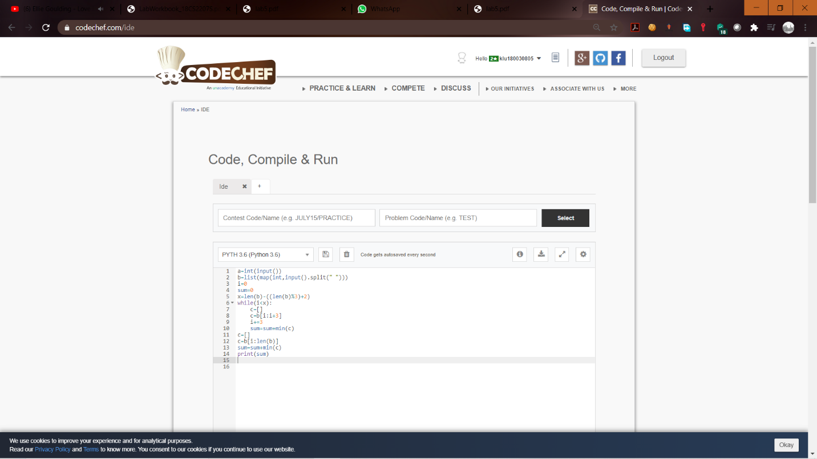

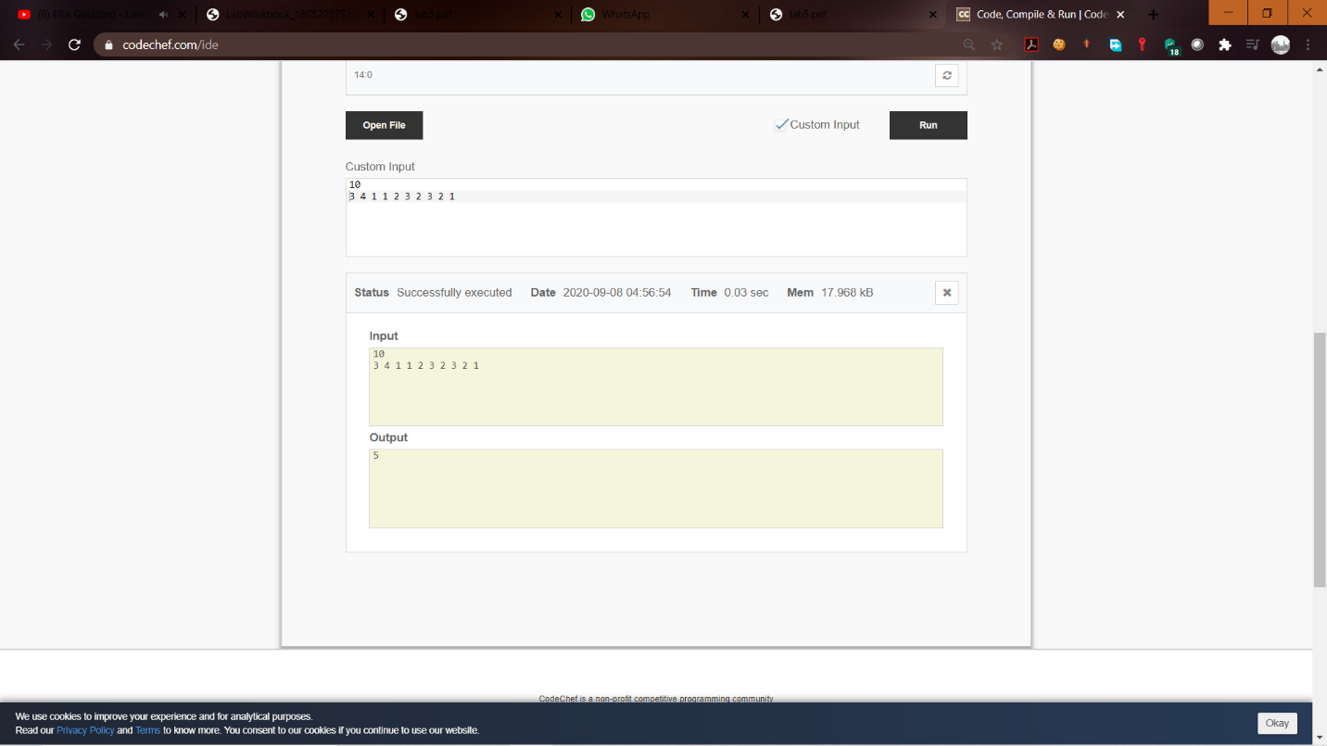

1. Given a string Str of characters from 1 to 9. Your task is print a string Str1 of numbers using dynamic programming such that a. |Str1|=|Str| b. The ith character of Str1 is the number of even characters from ith position to last position of Str. Input: A string S Output: A string of length |S| satisfying above conditions.

Sample Input:475854637834259

Sample output:766655433322100

Code: a=input()

b=[]

c=0

for i in range(len(a)):

b.append(int(a[i]))

if(b[i]%2==0):

c+=1

d=""

for i in range(len(b)):

if(b[i]%2==0):

d=d+str(c)

c-=1

else:

d=d+str(c)

print(d)

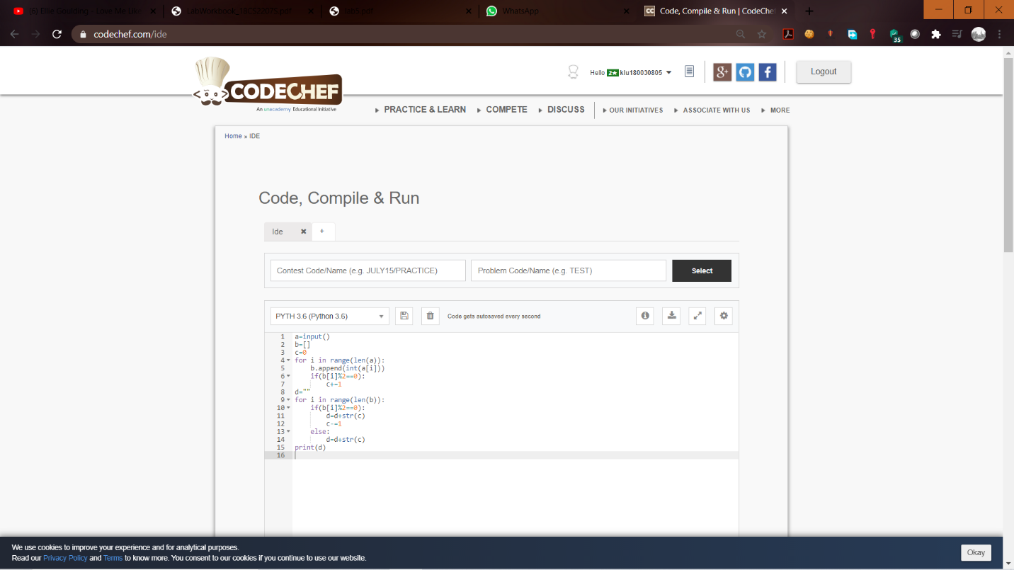

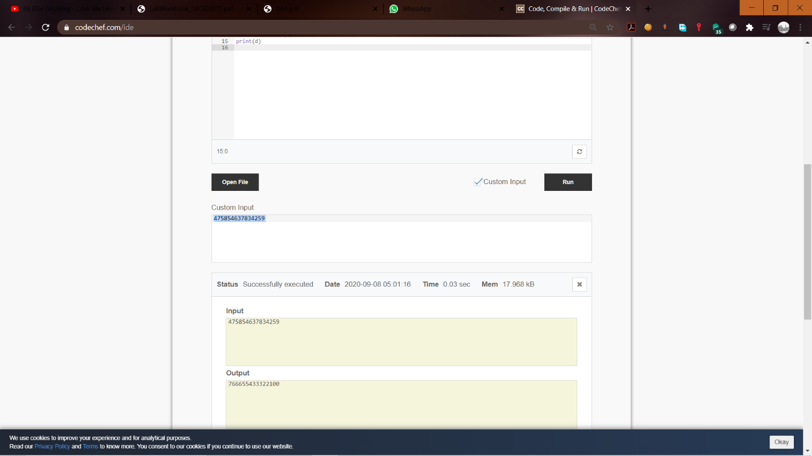

**INLAB**

3) In KL University, there is scheduled hours for playing cricket every day. You will be given number of days and hours you need to spend in each day. The rule here is that you have to skip one day in consecutive three days. Your task is to maximize your time in cricket by following the given rule Input: Line 1: An integer “n” representing number of days Line 2: n non negative integers representing the hours to spend on each day Output: A single non negative integer representing number of hours that you want to spend by following the given rule.

Sample Input: 1) 5 10 3 5 7 3 2) 8 3 2 3 2 3 5 1 3

Sample Output:) 23(10+3+7+3) 4) 17( 3+3+3+5+3)

Code: def find(arr, n):

left = [0]*n

right = [0]*n

water = 0

left[0] = arr[0]

for i in range( 1, n):

left[i] = max(left[i-1], arr[i])

right[n-1] = arr[n-1]

for i in range(n-2, -1, -1):

right[i] = max(right[i + 1], arr[i]);

for i in range(0, n):

water += min(left[i], right[i]) - arr[i]

return water

arr = [10,3,7,3]

n = 5

print(sum(arr))

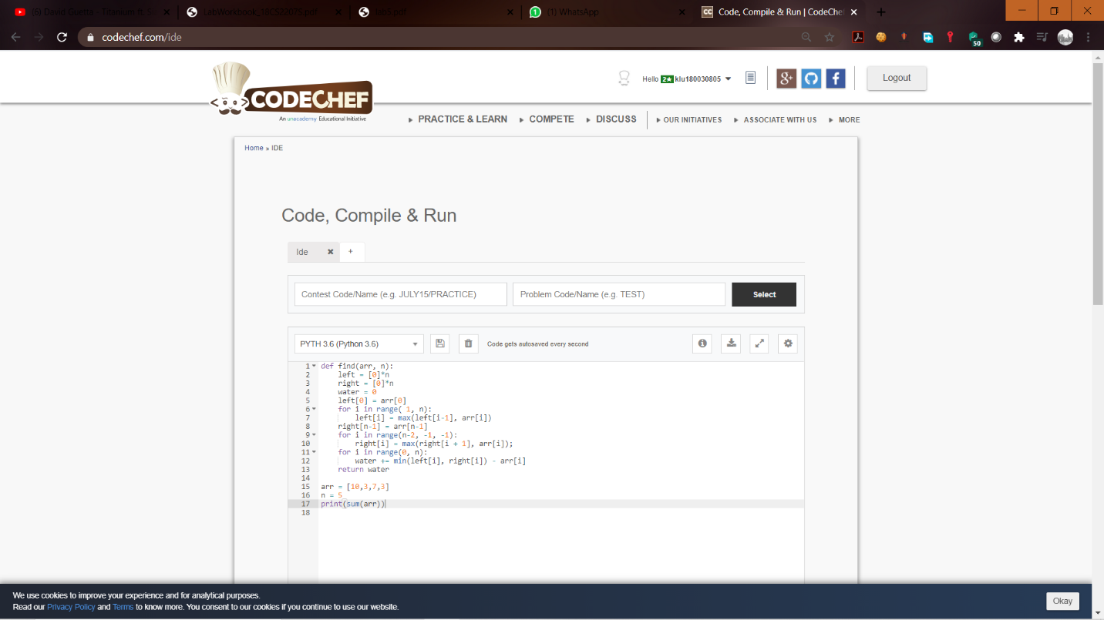

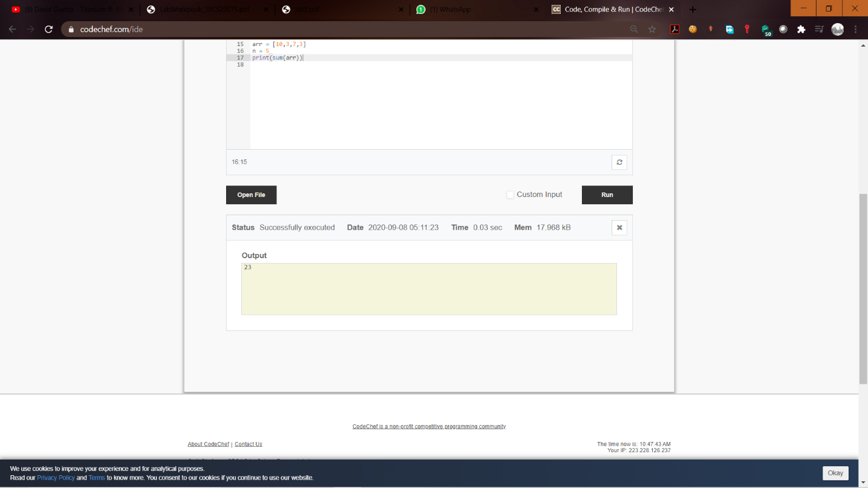

4) A sequence of numbers are called symmetric if it reads the same in both directions. For example 32,25,32 is symmetric. Every sequence of one number is symmetric. Any sequence can be broken up into parts such that each of them is symmetric. For an instance consider the sequence 25,35,25,53,45. It can be broken up into 3 symmetric sequences (25,35,25;53;45) or 5 symmetric sequences(25;35;25;53;45). Your task is to find the smallest number x such that the given sequence can be broken up into x symmetric sequences using dynamic programming. Input: First line contains, n, number of values in the sequence Second line contains n +ve integers Output: A single integer giving the smallest number x so that the given sequence can broken up into x symmetric sequences.

Sample Input: 5 25 35 25 53 45

Sample Output: 3

Code: a=int(input())

b=list(map(int,input().split(" ")))

x=0

c=list(set(b))

for i in range(len(c)):

d=b.count(c[i])

if(d>=2):

x+=1

x=len(b)-(x*2)

print(x)

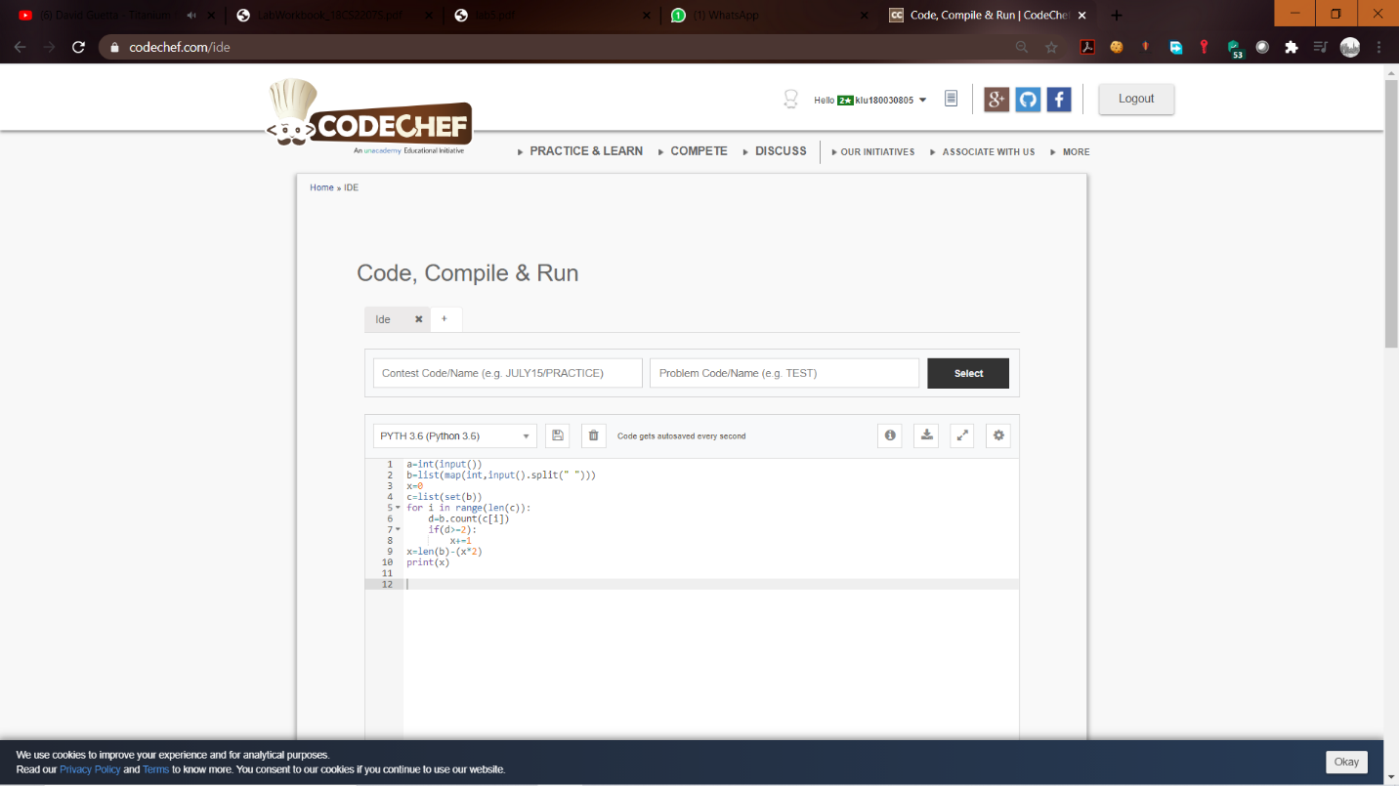

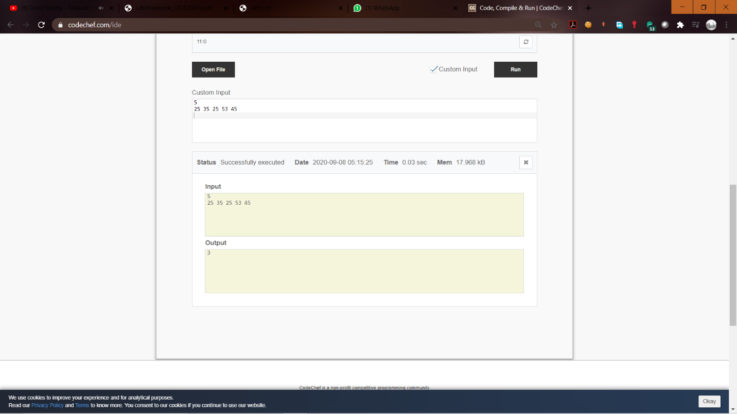

**POSTLAB**

6) Given N numbers n1,n2,…nN and Q quaries q1,q2,…qQ. Your task is to print Q numbers f1,f2,…fQ, corresponding to query qj1 ≤ j ≤ Q fj =max(n1 ,n2 ,...nq )using dynamic programming. Input: First line two +ve integers N and Q Second line n1,n2,…nN Third line q1,q2,…qQ Output: f1 f2 . . . fQ

Sample Input: 5 3 5 4 8 6 9 2 3 5

Sample Output: 5 8 9

Code: a=input().split(" ")

b=list(map(int,input().split(" ")))

c=list(map(int,input().split(" ")))

for i in range(len(c)):

d=[]

d=b[0:c[i]]

print(max(d))

